Chapter 18, Solution 38.

Using Fig. 18.40, design a problem to help other students to better understand using Fourier transforms to do circuit analysis.

Although there are many ways to solve this problem, this is an example based on the same kind of problem asked in the third edition.

Problem

Suppose v_{s}(t) = u(t) for t>0. Determine i(t) in the circuit of Fig. 18.40 using Fourier transform.

1 Ω
+
_
i

v_{s} 1 H

Figure 18.40 For Prob. 18.38.

Solution

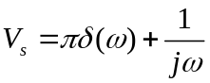
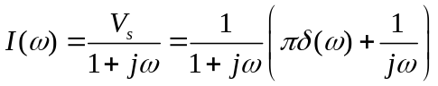
Let 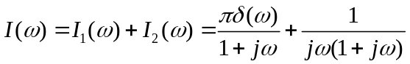
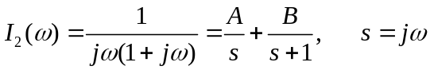

where 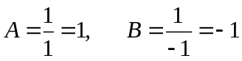

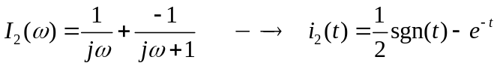
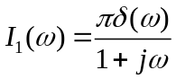
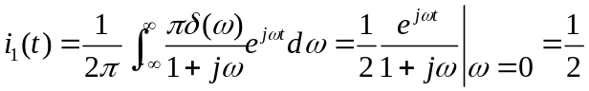

Hence,
